For everything:

Always mark when waveform going up (superceded by clear differences in waveform, see m2 exp amb ‘tennessee’)

How to re-annotate synthed tokens? See F1-amb “ambition”

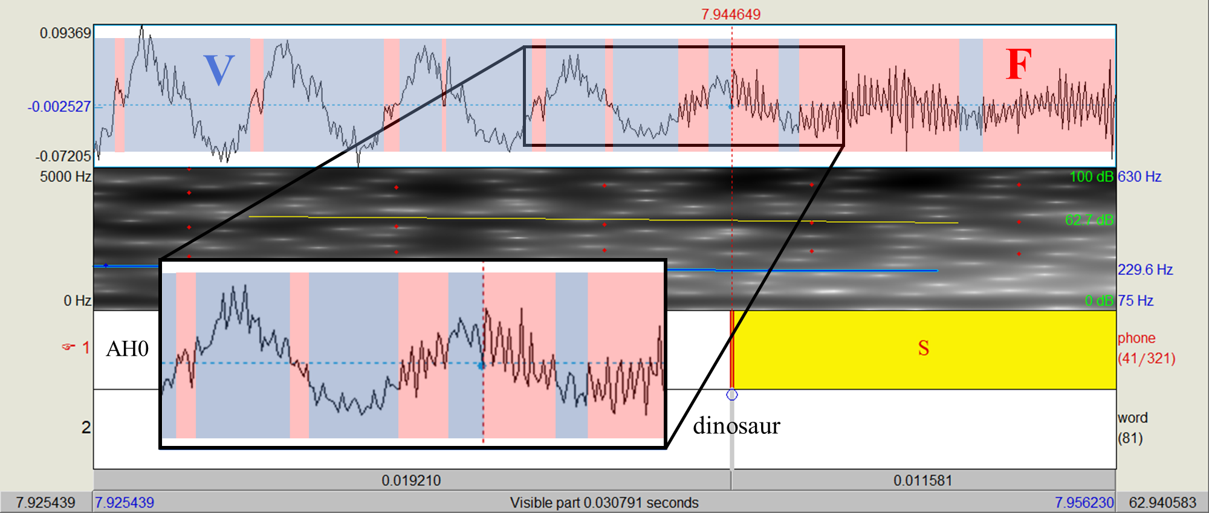

*Figure 1:* **Fricative Onset Preceded by Periodic Sound:** a 30-millisecond timespan around the fricative onset of /s/ in the word “dinosaur” (Samuel 2016). Spans where each direction change of the waveform results in a zero crossing are marked as ‘red’ zones. The onset boundary of a fricative after a vowel (or other periodic sound) is marked at the *first ‘red’ zone which is longer in duration than both surrounding ‘blue’ zones* (areas where direction changes do not result in zero crossings). The area marked “V” designates the vowel –predominantly ‘blue’ zones--, while the area marked “F” designates the fricative.

*Figure 4:* **Fricative Offset Succeeded by Periodic Sound:** a 30-millisecond timespan around the fricative offset of /s/ in the word “coliseum” (Samuel 2016). The area marked “F” shows clear frication (many zero crossings and high energy in the spectrogram), and the area marked “V” shows the first four clear periods of the /i/ vowel. The fricative offset is marked at the zero crossing immediately preceding the first of these periods.

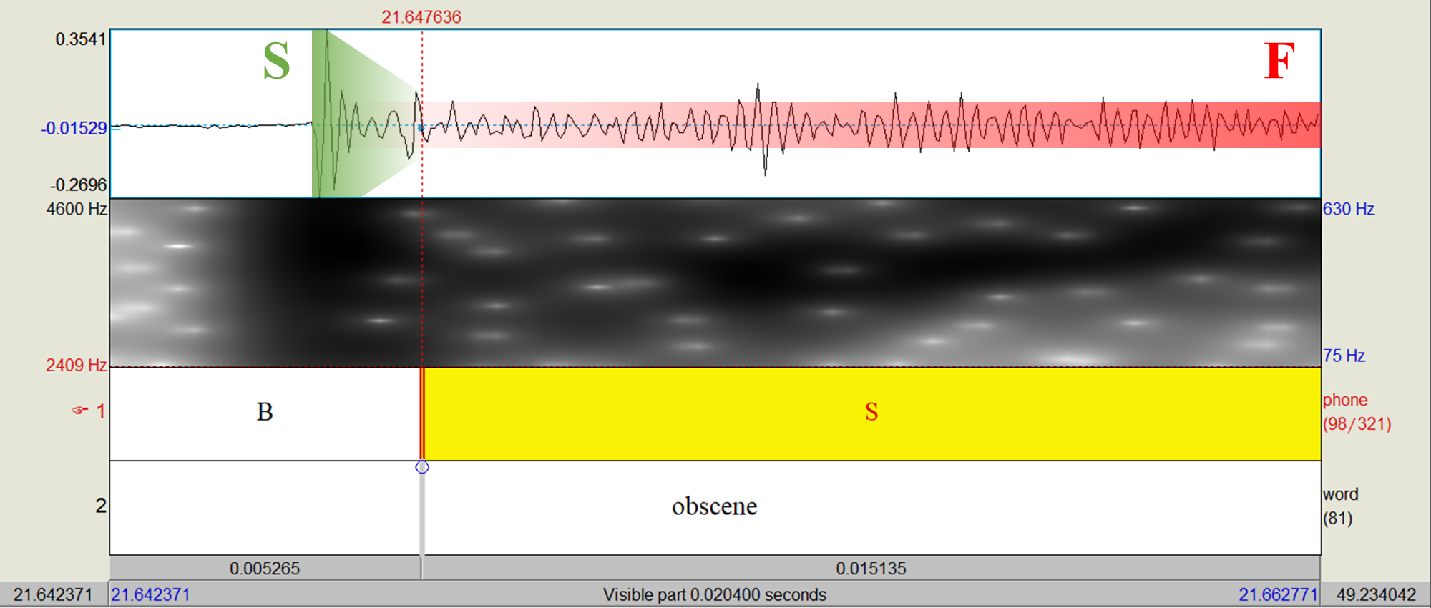

*Figure 2:* **Fricative Onset Preceded by a Stop:** a 20-millisecond timespan around the fricative onset of /s/ in the word “obscene” (Samuel 2016). The area marked “S” shows a typical plosive waveform with a strong spike that quickly diminishes. The area marked “F” shows the fricative waveform; the vertical boundaries show the approximate average height of the peaks. The boundary is marked where the decline in waveform amplitude of the stop meets the average amplitude of the fricative.

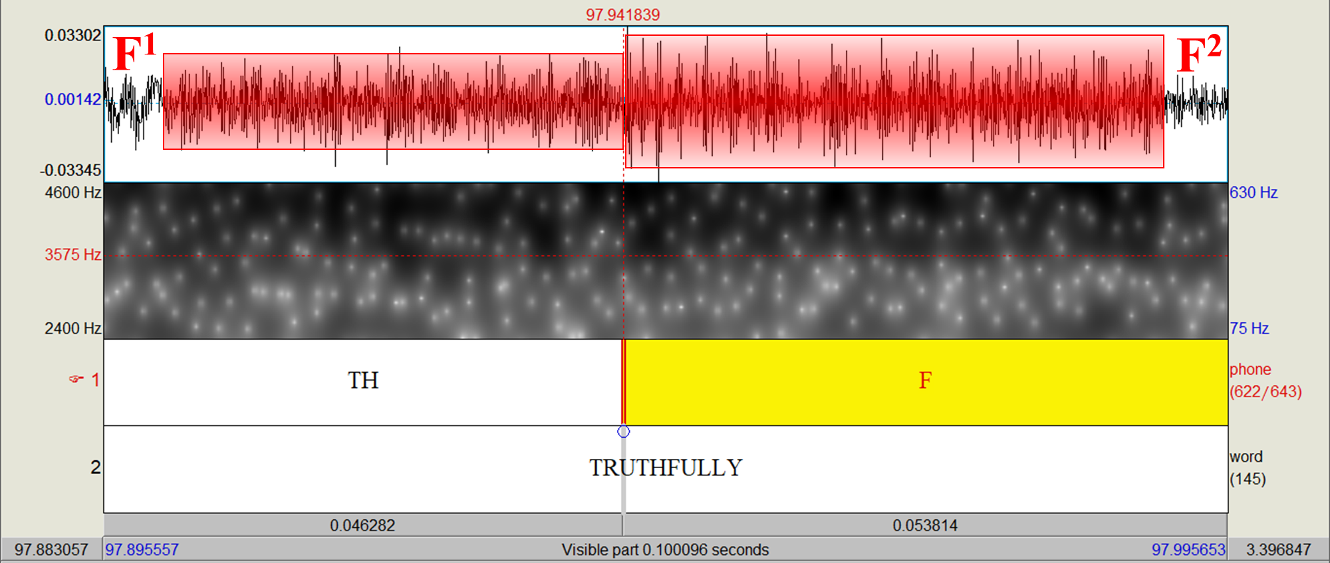

*Figure 3:* **Fricative Onset Preceded by another Fricative:** a 100-millisecond timespan around the fricative onset of /f/ in the word “truthfully” (Zhang & Samuel 2014). The area marked “F1” shows the waveform of a /θ/ fricative, while the area marked “F2” shows the /f/. The boundary is marked where the average peak amplitude of the waveform jumps.